TUTORIAL 1
QUESTION 2
NAME: AKSHAT AGARWAL
REGISTRATION NUMBER: RA2411042010060
DEPARTMENT: CSBS
SEMESTER: 2ND SEMESTER

QUESTION 2
Imagine you are designing a Student class. In this class, the student’s name should be directly accessible (public), but the id should be private and accessible only through a getter function.

(a) How would you declare the Student class with a public name member and a private id member?
(b) Provide a code snippet that demonstrates creating a Student object, directly modifying the name, and accessing the id via its getter function.
(c) Why might a designer choose to allow direct access to some members while restricting others?

SOLUTION
PART A:
The Student class should have a public name member and a private id member. The private id should only be accessible through a getter function.

PART B:
SOLUTION
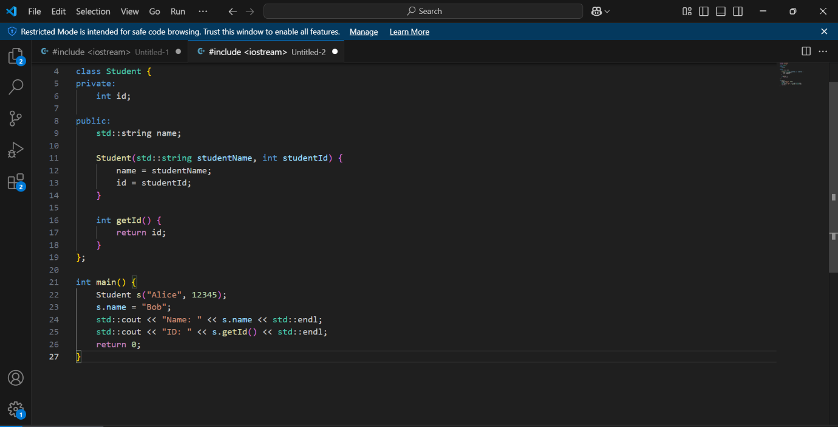
PART C:
(c) A designer might allow direct access to some members while restricting others to maintain data integrity and encapsulation. For example, a student's name might be safe to modify directly, but the ID should be protected to prevent accidental or unauthorized changes.

